Architecture Diagram:

The given FD Safety Alerts solution has been implemented using some of the layers from the SOA compliant architecture as shown below which enables systems and applications to connect each other seamlessly. Please note some of the unused layers for the FDAlerts solution have been removed from the diagram.

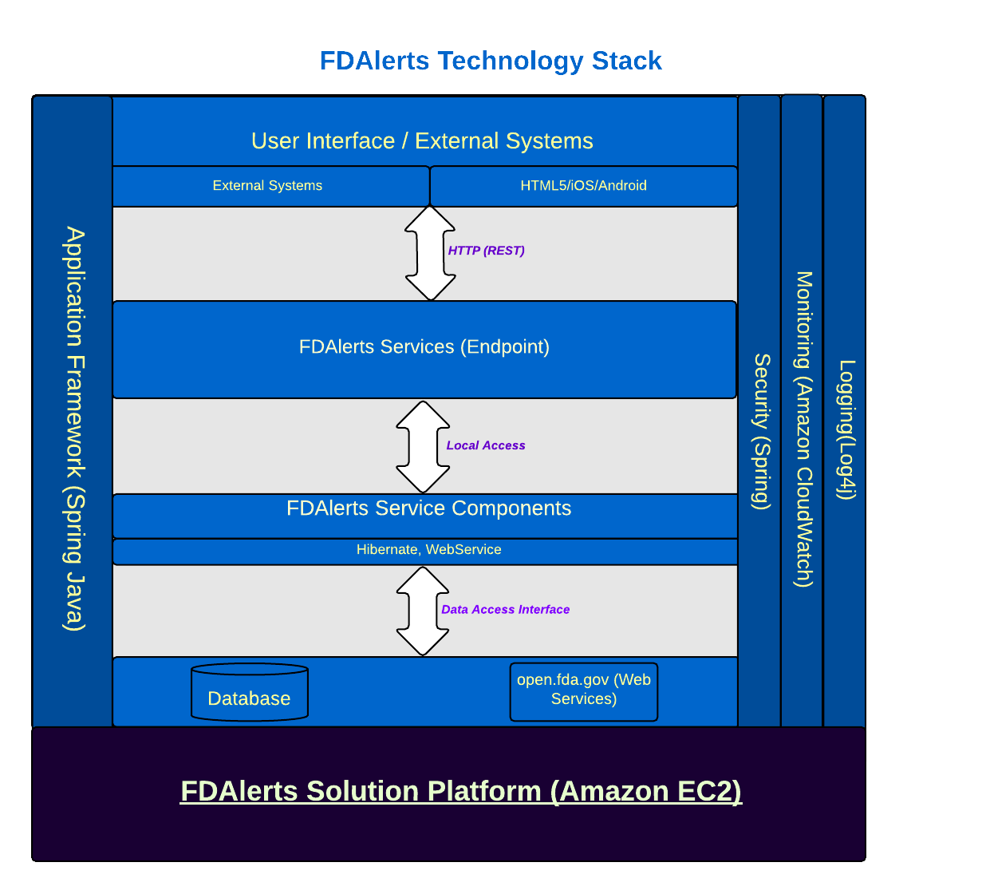

Following are the core capabilities:

* Provides separation of Presentation/Consumer layer, Services, Business Service Components and supporting systems/applications from one another
* Provides support for building systems/applications that facilitates loosely coupled integration and provides flexibility to change through the use of Services
* Supports interaction patterns such as synchronous (request/response) and asynchronous (i.e. email), and pub/sub between consumers and service providers
* Supports all standard protocols for interactions between different layers and also provides interoperability among all components
* The services consists of all the services including both Web Services and micro-services. The service specification includes a description of the abstract functionality offered by any service in the form of a JSON Schema. The micro-services reside in this layer can be discovered and invoked or possibly choreographed to create a composite service (web service) for consumers to get details of device,food and drugs services on open.fda.gov. Following are a list of few web services (endpoints) that are consumed and produced by FDAlerts:
  + As a consumer:
    - [https://api.fda.gov/drug/enforcement.json?search=report_date:[20040101+TO+20131231]&limit=1](https://api.fda.gov/drug/enforcement.json?search=report_date:%5b20040101+TO+20131231%5d&limit=1)
    - [https://api.fda.gov/device/event.json?search=date_received:[20130101+TO+20141231]&limit=1](https://api.fda.gov/device/event.json?search=date_received:%5b20130101+TO+20141231%5d&limit=1)
    - https://api.fda.gov/food/enforcement.json?search=report_date:[20040101+TO+20131231]&limit=1
  + As a producer:
    - [http://ec2-52-5-29-80.compute-1.amazonaws.com:8080/rigil-18f/user](https://localhost:9999/rigil-18f/user)
    - https://[ec2-52-5-29-80.compute-1.amazonaws.com:8080/rigil-18f](https://localhost:9999/rigil-18f/user)/fdadata